1) In-order Traversal
Left -> Root -> Right

2) Post-order
Left -> Right -> Root

3) Pre-order
Root -> Left -> Right

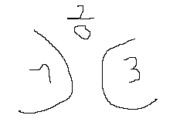
1) In-order Traversal
Left (1) -> Root (2) -> Right (3)

2) Pre-order
Root (2) -> Left (1) -> Right (3)

3) Post-order
Left (1) -> Right (3) -> Root (2)

